**Selenium:** it is basically a software testing tool. It is automated and very easy to use. We use it mainly because it is open source and free for all. Before we start our testing process we need to install some tools and environment variables.

1. Installing Java development kit or JDK.  
     
   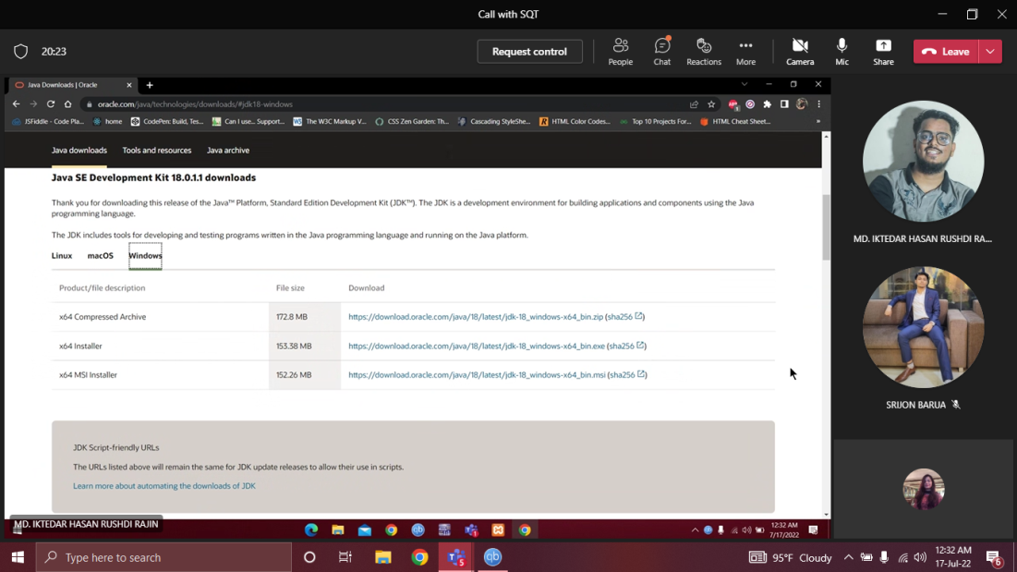
2. Installing Eclipse IDE for java.  
     
   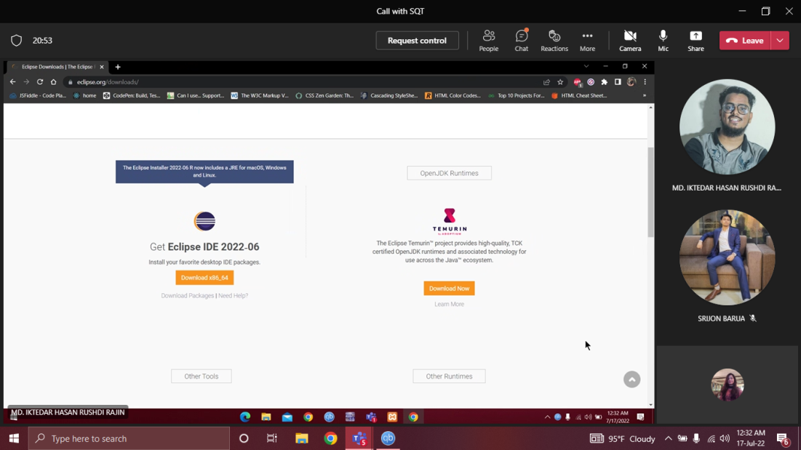
3. Install Selenium stale release 4.3.0  
     
   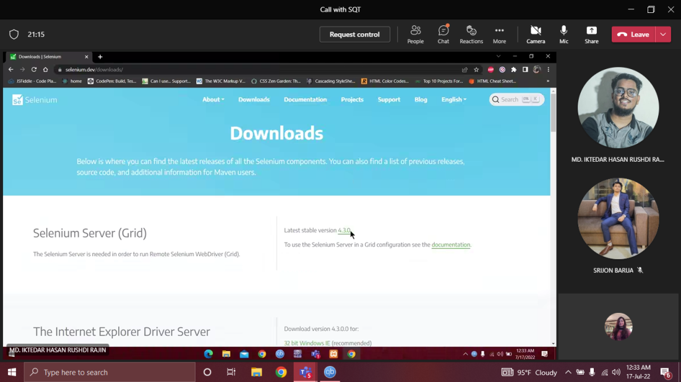
4. Download ChromeDriver  
     
   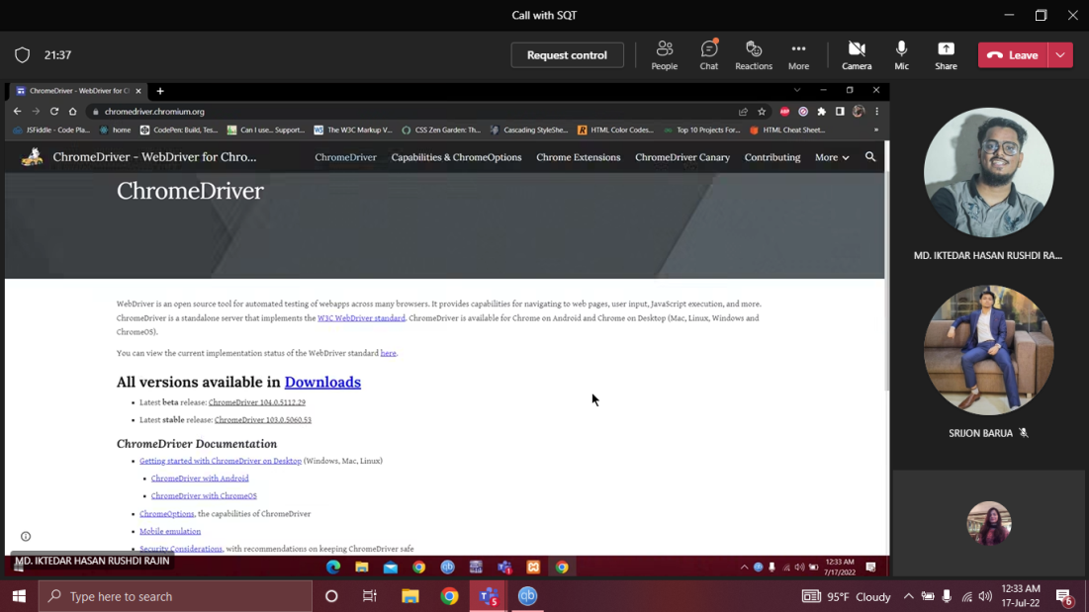

Once the installation is finished, we now need to do the following steps to test a Web application using selenium.

1. Open eclipse and create a new java project and name it “SQT_ASSIGNMENT”.  
     
   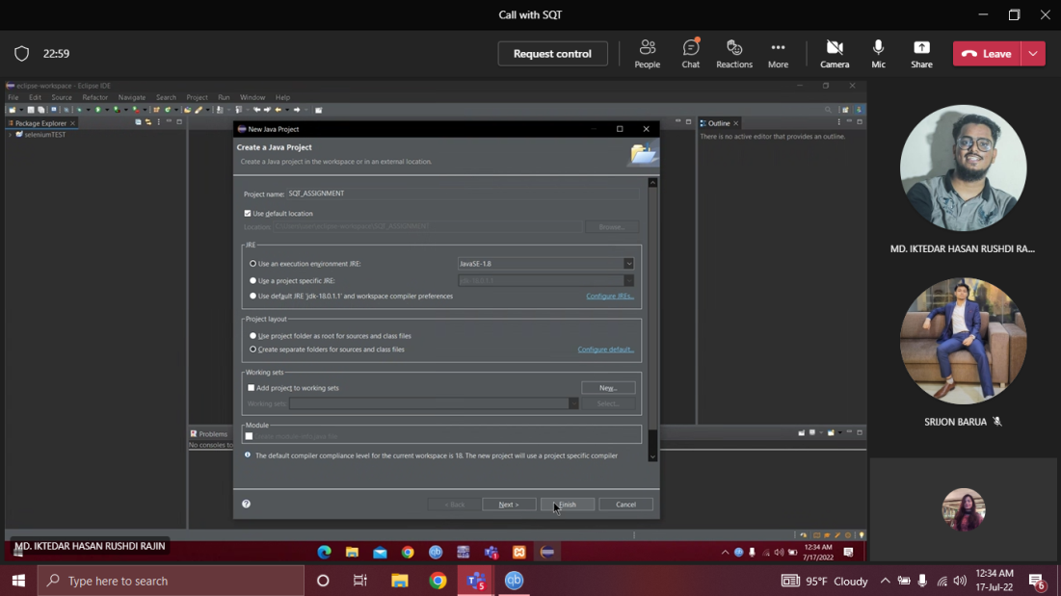
2. Under the project we opened a new package named “LoginTest”  
     
   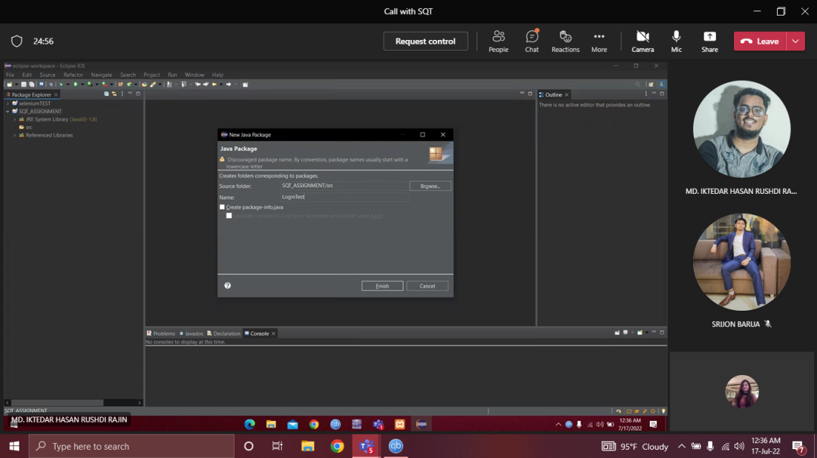
3. Under the package we created a class named “MyTestLogin”.  
     
   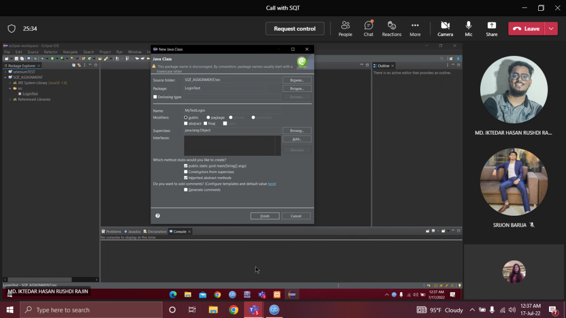
4. Now we have to include the selenium server as .jar file. Build path>configure build path>inside libraries> add external jar files> apply.  
     
   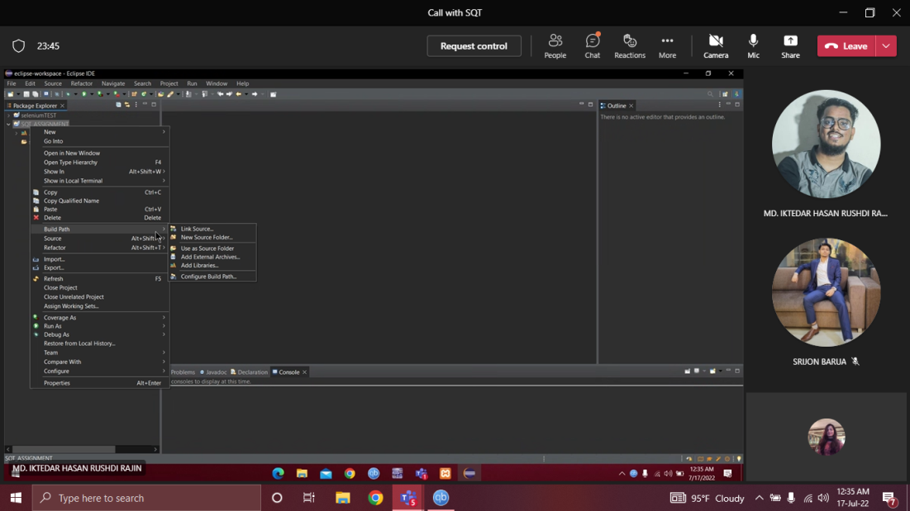  
     
   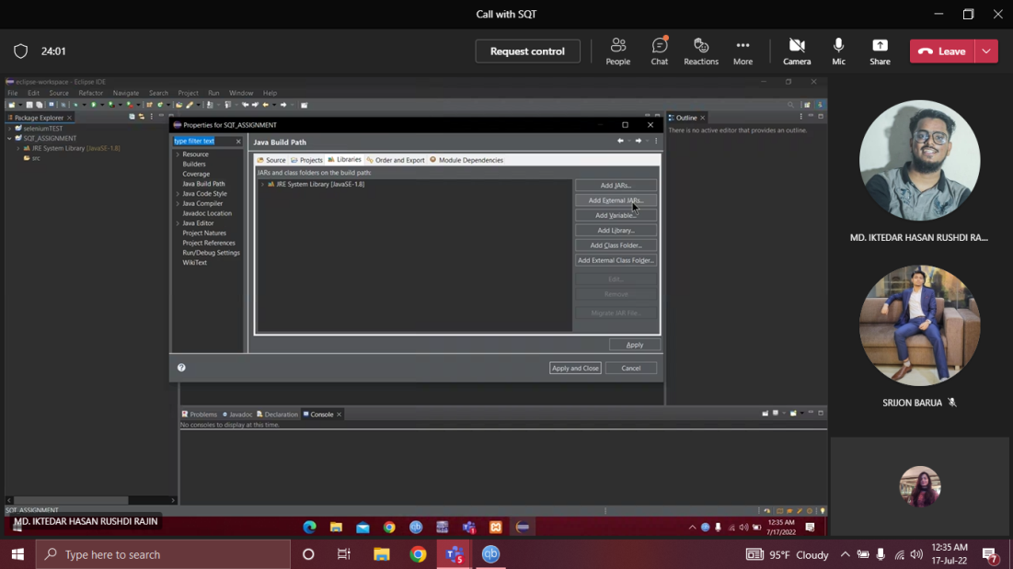  
     
   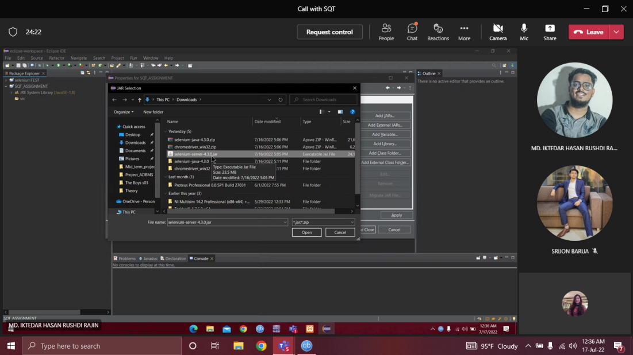
5. Inside the MyTestLogin.java file we wrote the following code.

*package LoginTest;*

*import org.openqa.selenium.By;*

*import org.openqa.selenium.WebDriver;*

*import org.openqa.selenium.chrome.ChromeDriver;*

*public class MyTestLogin {*

*public static void main(String[] args) throws InterruptedException {*

*System.setProperty("webdriver.chrome.driver","C:\\Users\\user\\Downloads\\chromedriver_win32\\chromedriver.exe");*

*WebDriver driver = new ChromeDriver();*

*driver.get("http://localhost/Project_ADBMS/login-view.php");*

*driver.manage().window().maximize();*

*Thread.sleep(2000);*

*driver.findElement(By.id("email")).sendKeys("rushdi@gmail.com");*

*Thread.sleep(5000);*

*driver.findElement(By.id("pass")).sendKeys("1234");*

*Thread.sleep(5000);*

*driver.findElement(By.id("login-btn")).click();*

*Thread.sleep(5000);*

*String at = driver.getTitle();*

*String et = "dashboard";*

*System.****out****.println(at);*

*driver.close();*

*if(at.equalsIgnoreCase(et))*

*{*

*System.****out****.println("Test successful");*

*}*

*else*

*{*

*System.****out****.println("Test Failure");*

*}*

*}*

}

6

1. After building and running the code. It loads the website in the chrome window. Then first it enters the email in the email field and password in the password field. After that it presses the login button. After that we are taken into the dashboard.  
     
   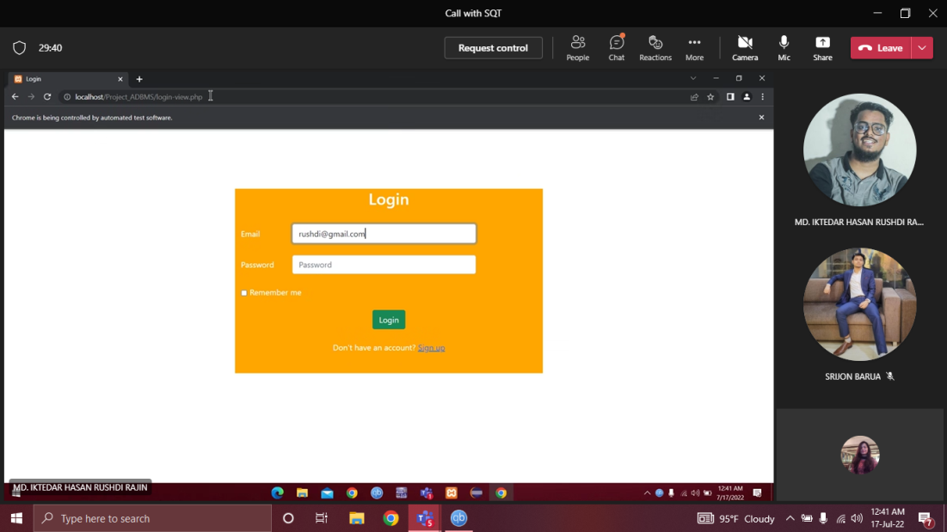  
     
   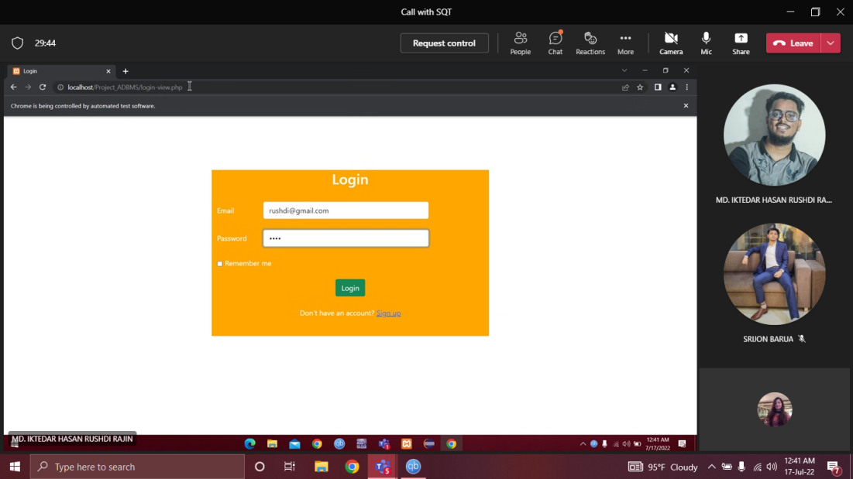  
     
   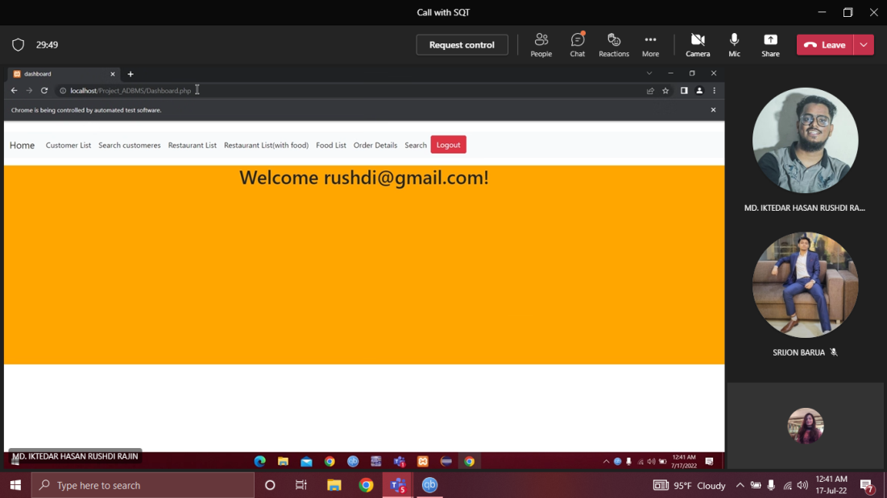
2. Since the testing was successful, we got a pop-up in our console, “Test Successful”, according to our code.

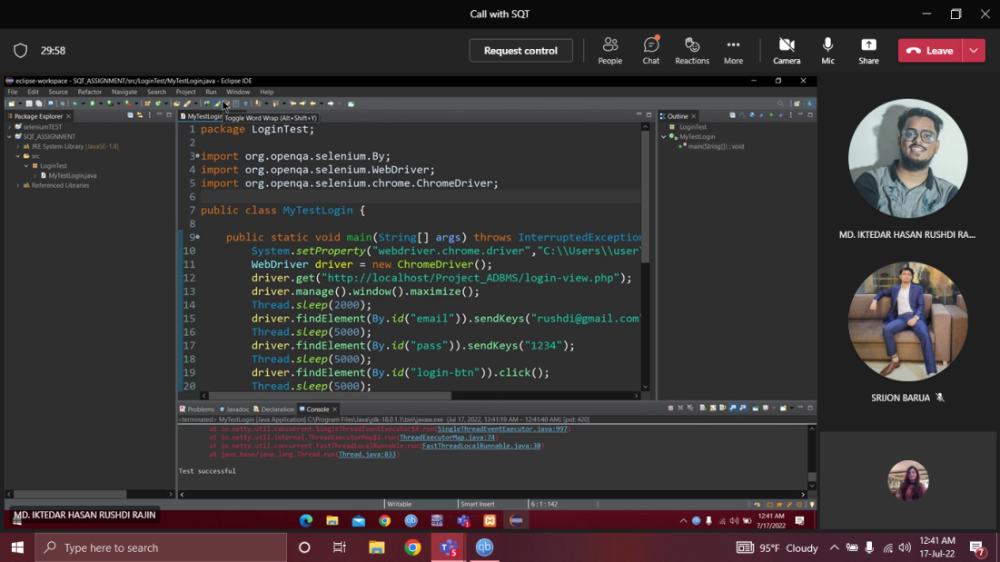

1. The flowchart for setup processes.  
     
   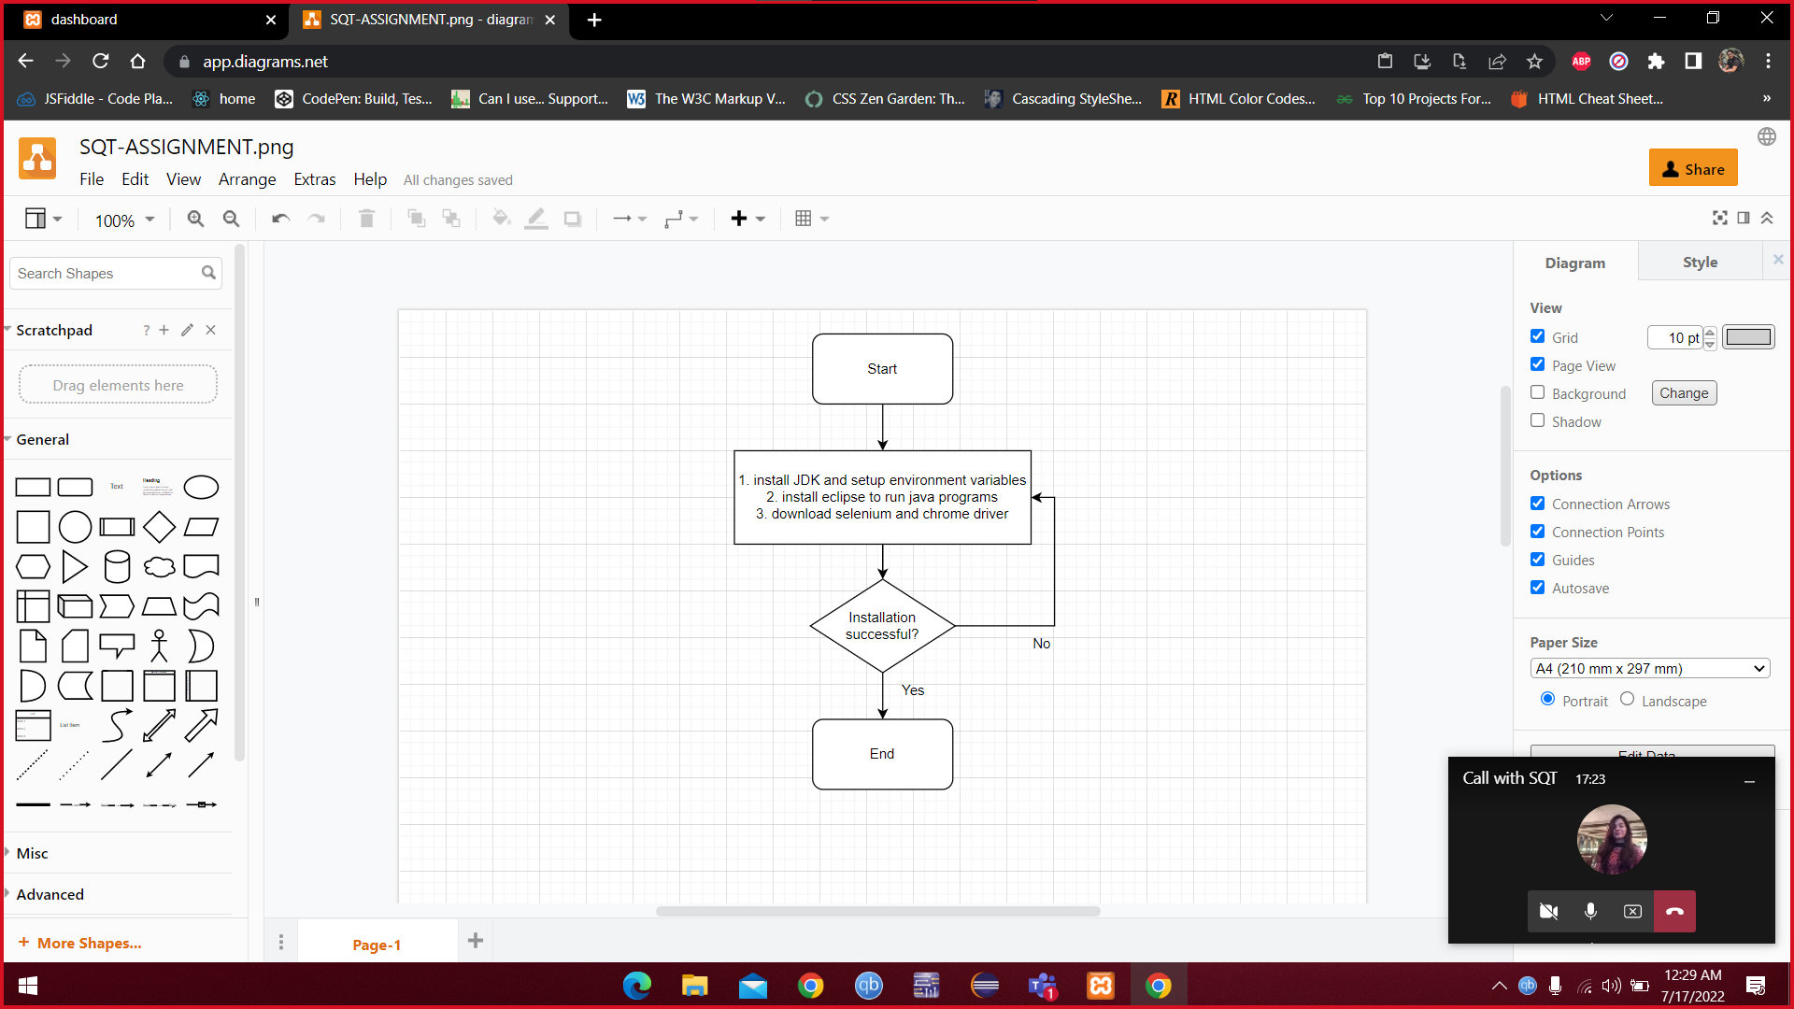
2. The flowchart for testing processes.  
     
   